Internship

**TestReport**

**Microscope LED**

**Student:** Casper R. Tak

**Studentnumber:** 657313

**Client**: Rudie van den Heuvel

**Coach:** Jeroen Veen

**High School:** HAN Arnhem

**Education:** Embedded Systems Engineering

**Date:** 07-11-2022

Inhoud

Objective 3

Test Setup 3

Test Results 4

Conclusions 4

Further actions 4

Later discoveries 4

# Objective

The component that will be tested in this test report will be the microscope LED. This component is responsible for creating sufficient light for the camera module.

# Test Setup

* Testing equipment:
  + Hardware:
    - LabNation Cross Platform Oscilloscope
  + Software:
    - VSC
    - SSH connection to RPI
    - Smartscope
* Setup hardware/software

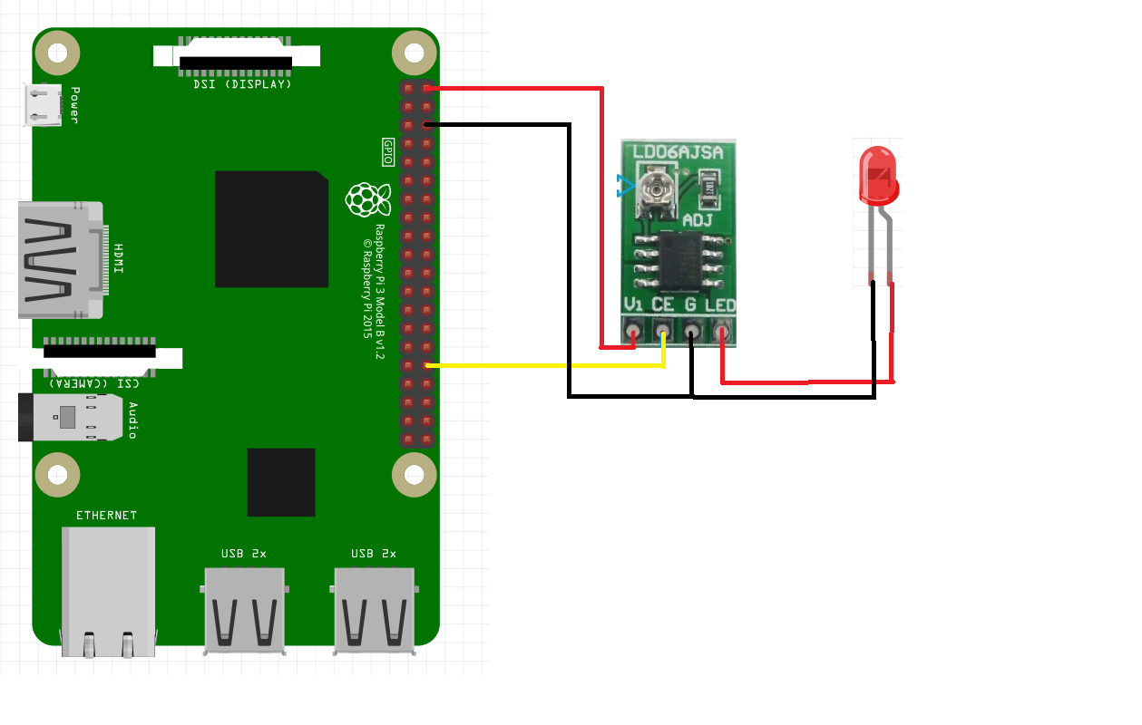

# Test Results

|  |  |  |  |  |  |  |
| --- | --- | --- | --- | --- | --- | --- |
| Test | Test passed if: | Observations | Test passed | Test Failed | Pictures | Notes |
| T1.0 | Device turns on | Device turns on | X |  |  |  |
| T1.1 | Device turns off | Device turns off | X |  |  | Expected 0V flat line, not this pwm wave |
| T1.2 | PWM control works | LED dims and brightens | X |  |  |  |

# Conclusions

* The LED functions

# Further actions

* Since the LED seems to be turned off enough to not be visible for the human eye it may be enough to leave things as they are regarding this strange signal.

# Later discoveries

* We figured out that the reason for the signal not going to zero was because the value of 0, was not actually zero but around 35000hz by a constant. We changed the value to 0 and now it works fine.